**LAB 10 Install FOG**

**Course Name**: Malware Analysis and Reverse Engineering (IAM302)

**Student Name**: Nguyễn Trần Vinh – SE160258

**Instructor Name**: Mai Hoàng Đỉnh

**Lab Due Date**: 22/2/2023

**Purpose**

* Install FOG

**What we need**

* Ubuntu workstation

**Step to step**

- sudo apt-get update && sudo apt-get upgrade && sudo apt-get autoremove

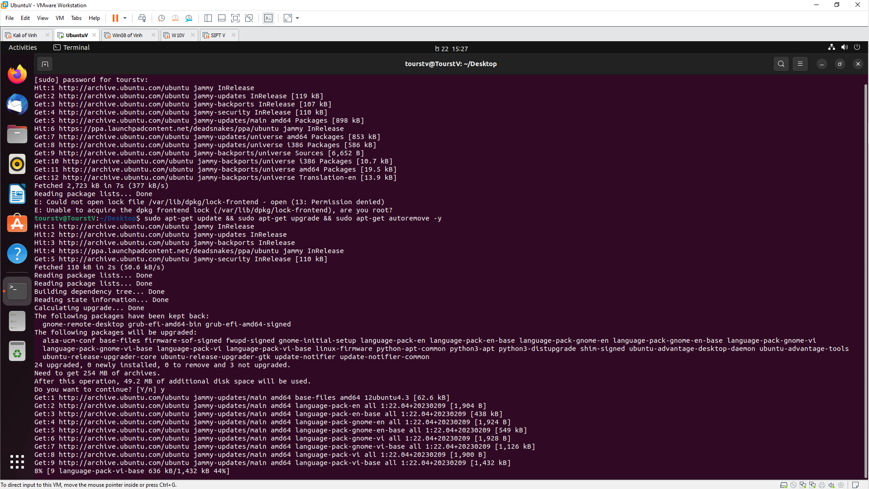

- sudo apt-get install python-software-properties 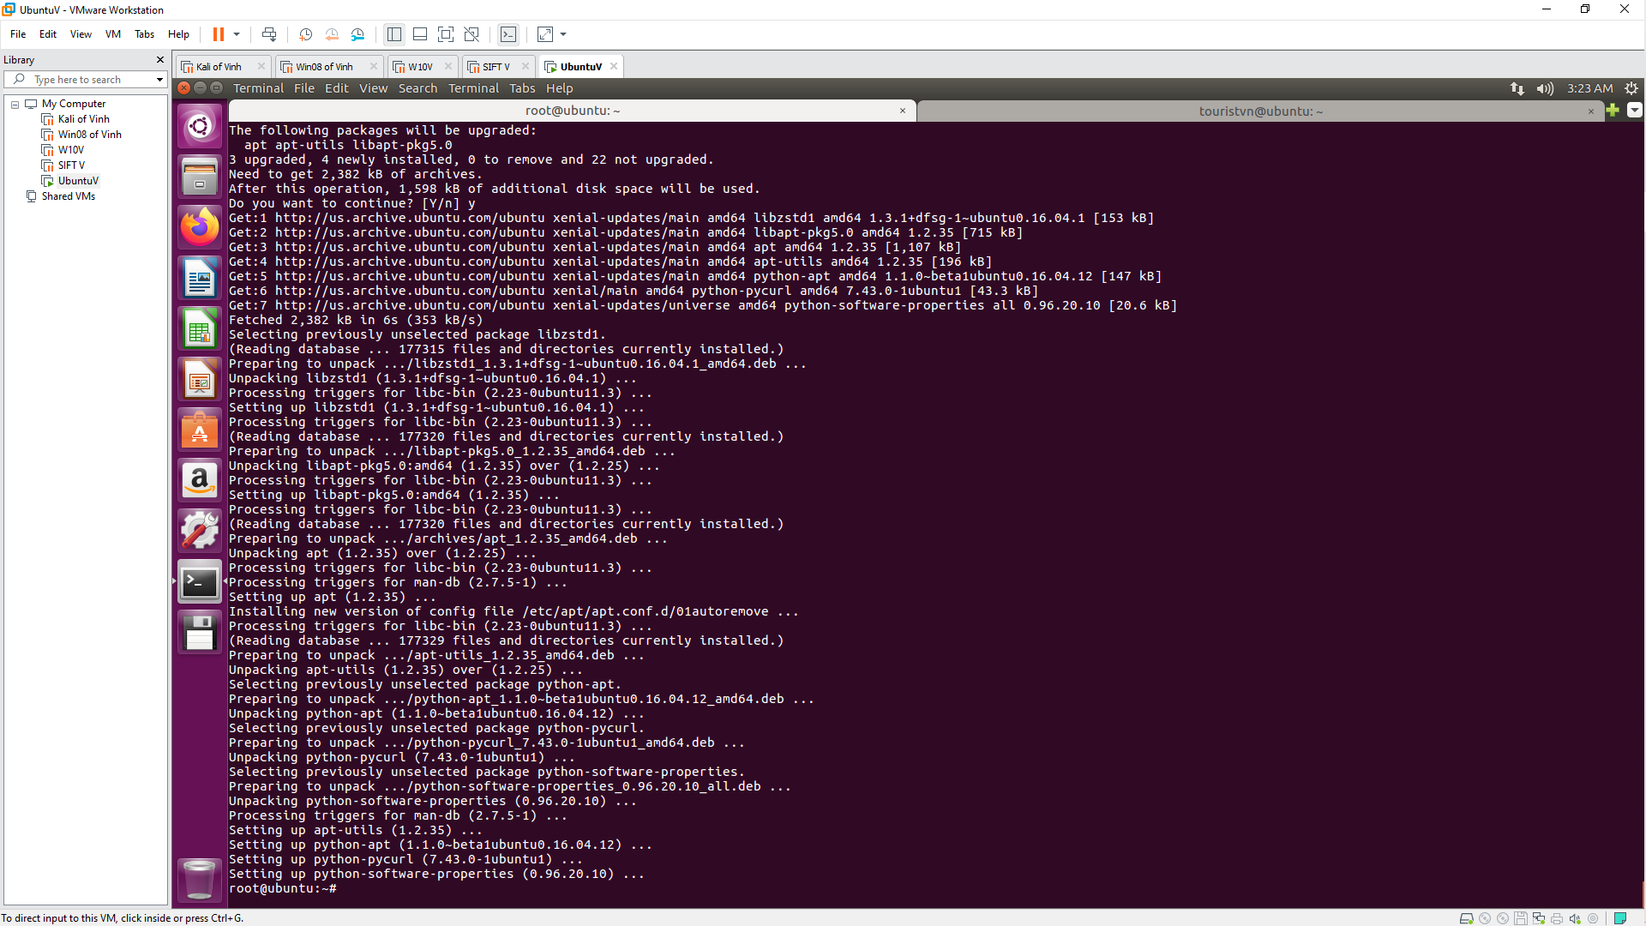

- sudo gedit /etc/network/interface

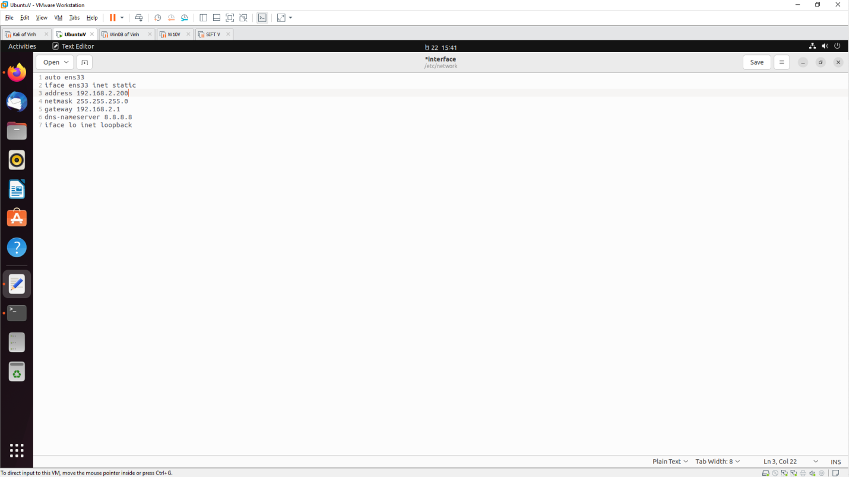

- sudo reboot now

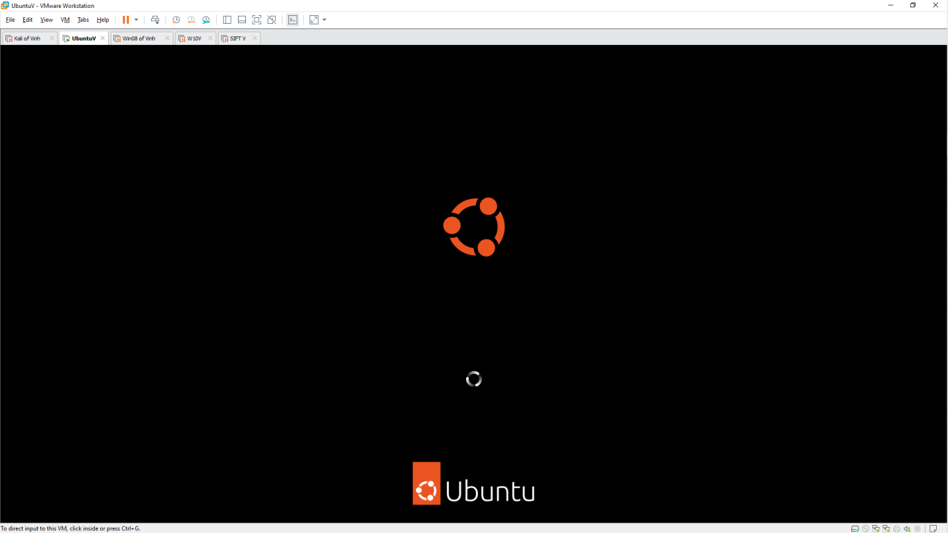

- git clone https://github.com/fogproject/fogproject.git fogproject-master

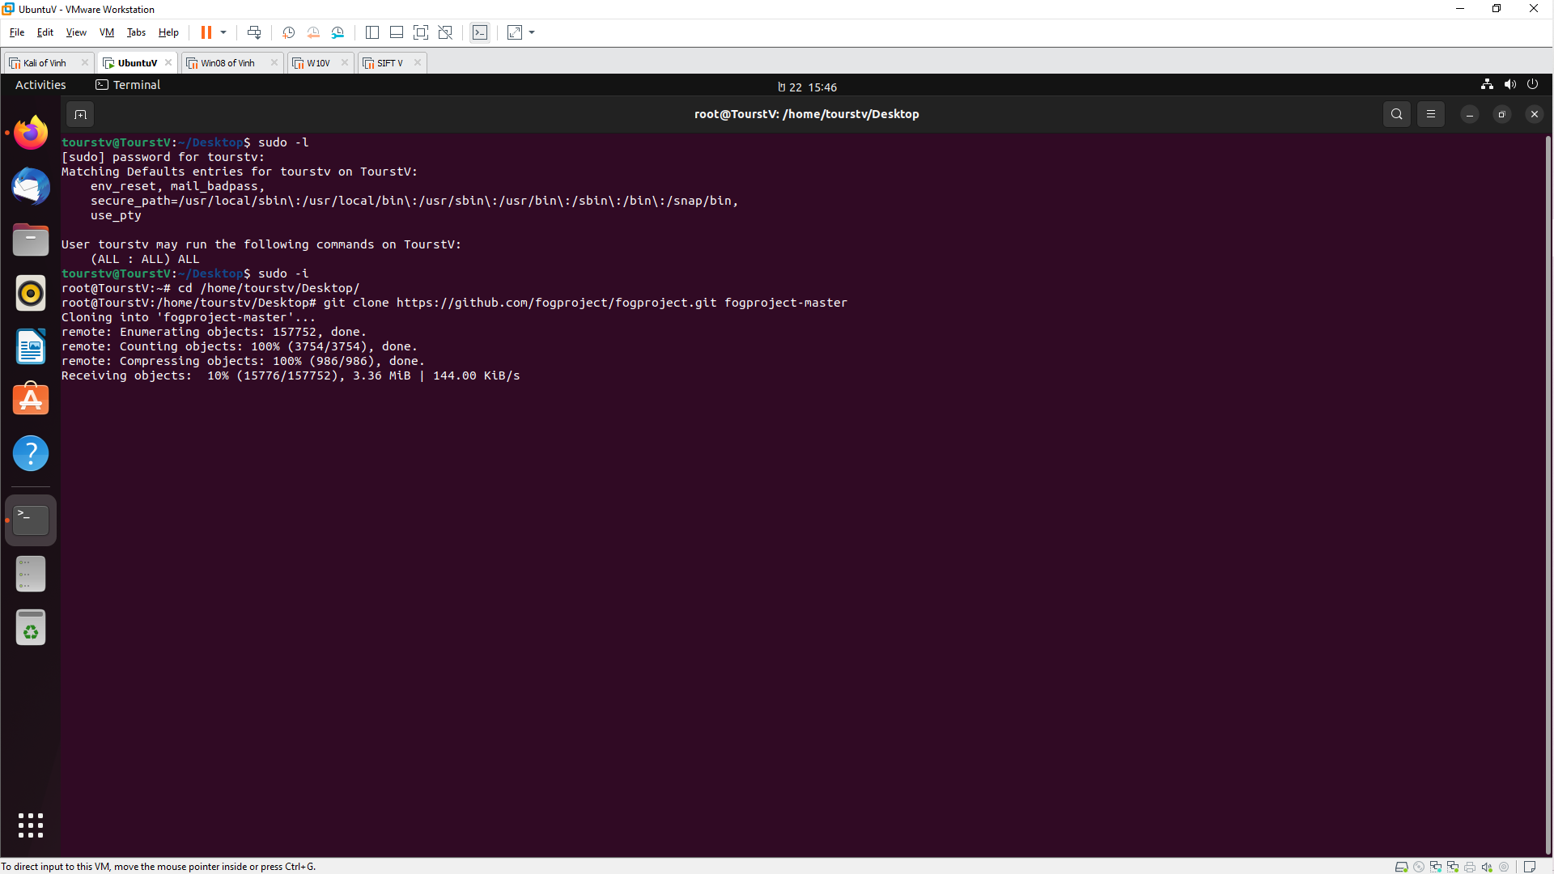

Because php7.1 does not exist in Ubuntu 16.04 so we need to change to php7.0 in /lib/ubuntu/config.sh

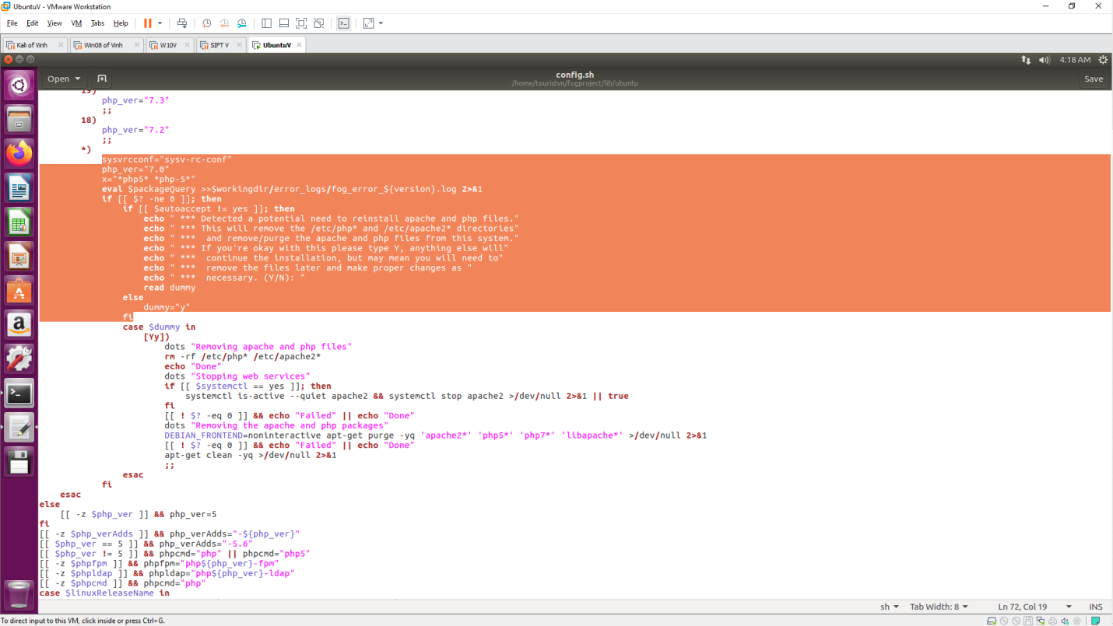

./installfog.sh

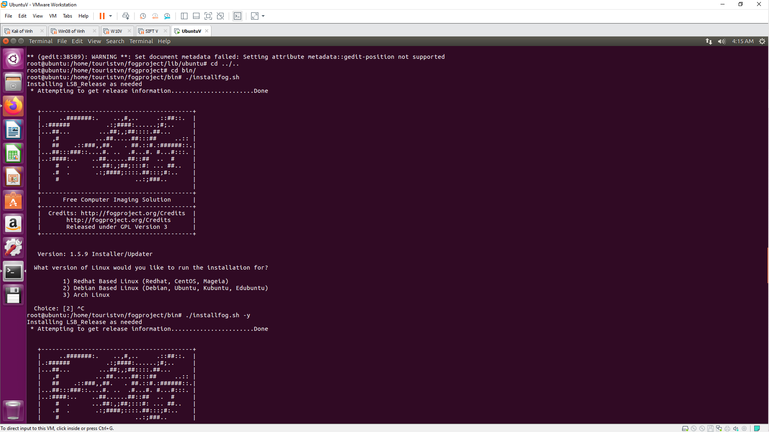 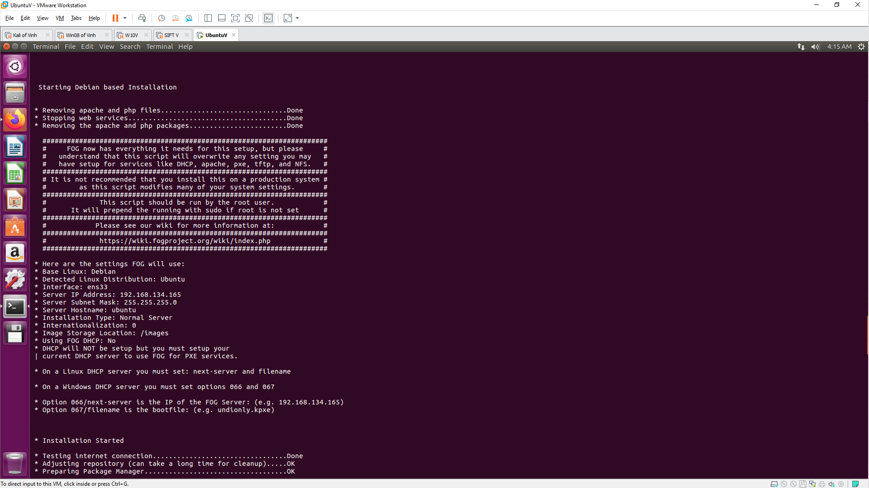 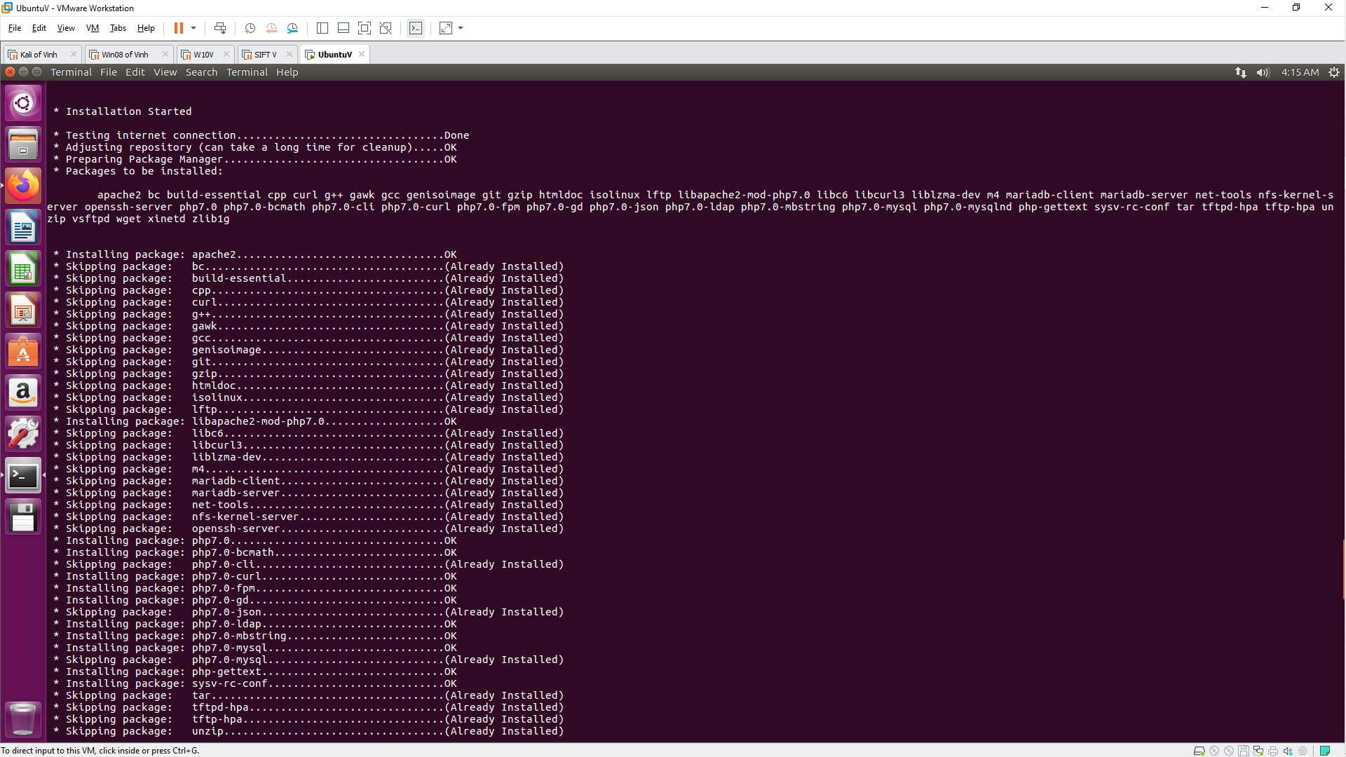 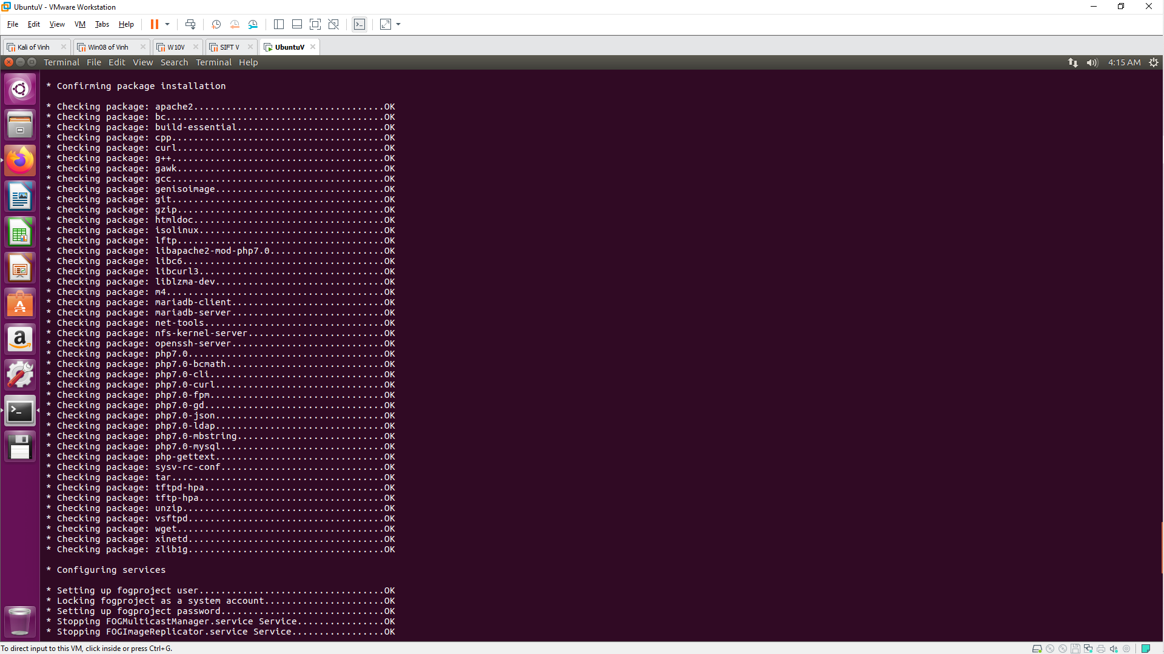 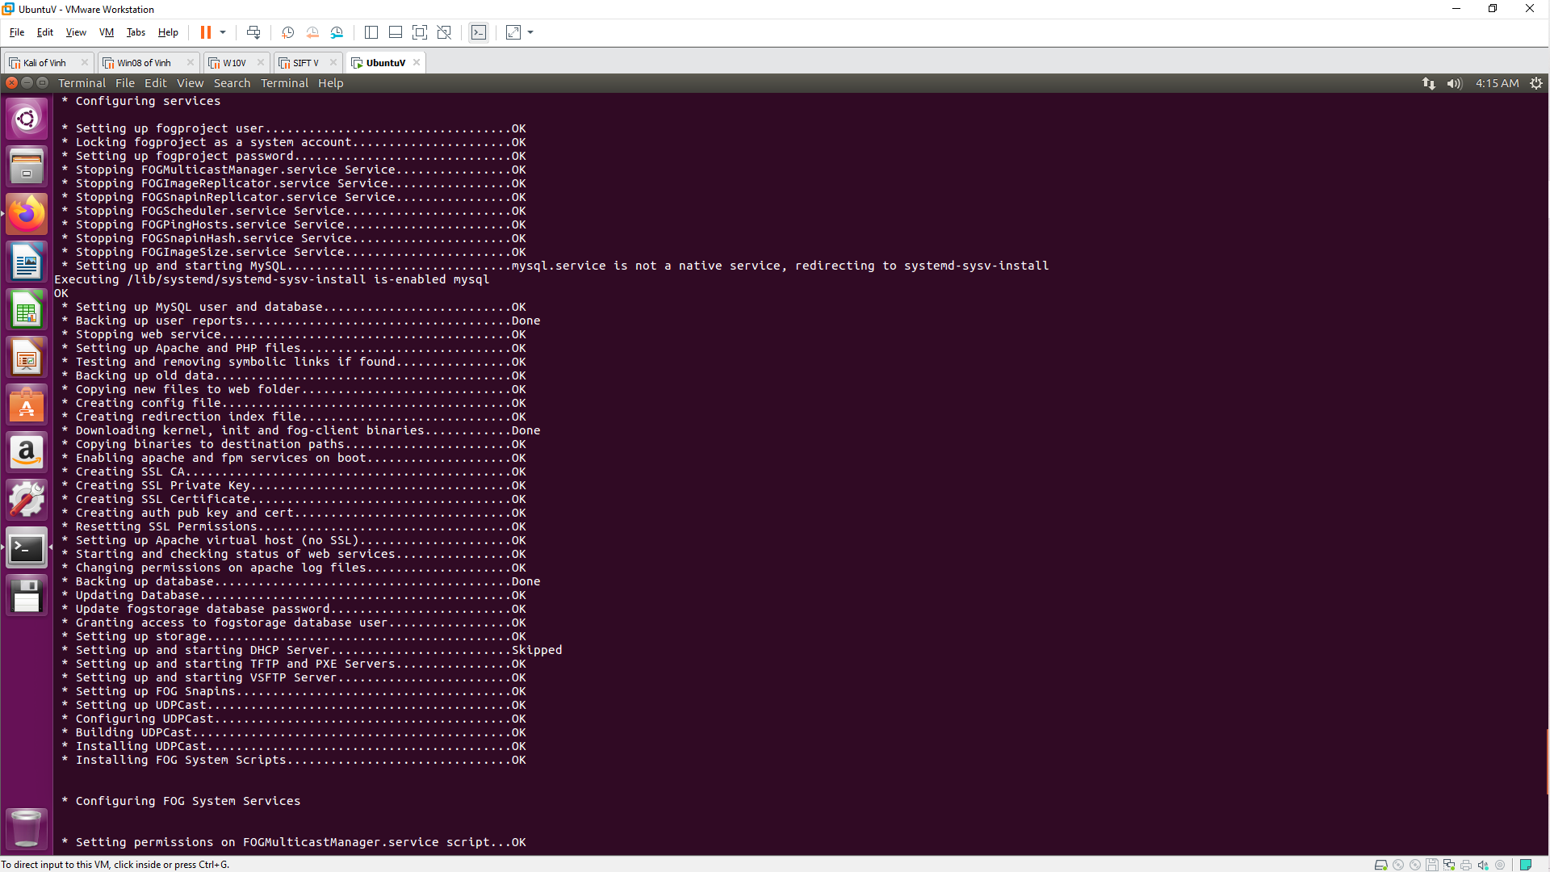 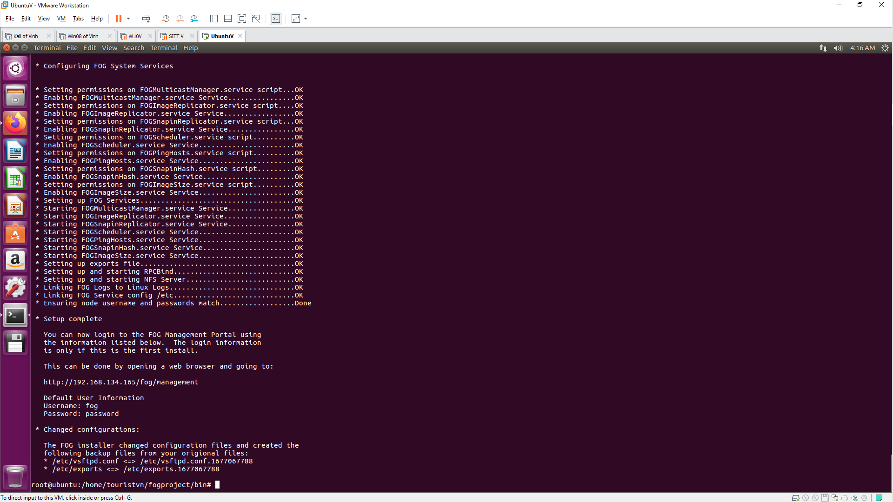

Login to <http://192.168.134.165/fog/management>

